Application for dog licence - required for all dogs aged 6 months or over
(except a guide dog for person who is blind or deaf)

Applicant Information
Full Name:
 | Last | First | Title.

Address:
Address

 | Address | Parish | Postcode

Phone: |  | Email:

Are you 16 years or older? | Yes | No | If no, we cannot issue you with a dog licence.

Details of dog(s) for which a licence is required
Dog name | Breed | Gender | Age/year of birth | Colour | Microchip no./other ID

Declaration and Signature
Payment: for every licence renewal made by 31 January or a new licence - £10 per dog
for every licence renewal from 1 February - £20 per dog
I have made payment of: insert £…………… Online (see Parish website)
Cheque (payable to ‘Parish of …’) Cash (in person only please)

I have read and understood the information overleaf outlining some of my responsibilities as a dog owner.
I certify that my answers are true and complete to the best of my knowledge.

Signature: Date:
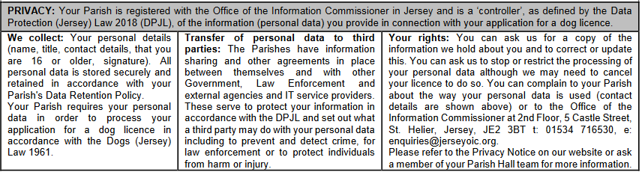

DOG OWNERSHIP IN JERSEY – your responsibilities
1. Dogs must be licensed by 31 January each year in the Parish in which the owner is resident (licence fee £10 per dog; late applications after 31 January are £20 per dog). A licence will not be issued to a person under the age of 16 years.
2. The licence is specific to a dog and cannot be transferred to another dog.
3. Dogs must wear a collar with the name, address AND telephone number of the owner inscribed on the collar (or a plate/badge attached to the collar) when on a highway or in a public place (a pack of hounds or a dog being used for sporting purposes/capture or destruction of vermin is exempt). It is not sufficient to have only a microchip or an identity number.
4. Dogs must be kept under proper control and must not worry livestock or be dangerous. Public liability insurance cover can generally be arranged through a household insurance policy and is recommended for all dogs.
5. If you change your address or you sell or rehome your dog, or your dog dies, please advise the Parish so our records may be updated. If your dog has a microchip you should also inform the Database provider of any change to the name or address of the owner so the details are correct.
6. Stray dogs:
a. If your dog is lost please report this to the Duty Centenier, Parish Hall or JSPCA.
b. If you find a stray dog please contact the owner (using the details shown on the collar). If you are unable to look after the dog until returned to the owner then contact the Duty Centenier or Parish Hall of the Parish where the dog is found or the JSPCA. Stray dogs will be taken into care and the owner will be liable for collection costs and housing costs incurred (collection £36 per journey leg; housing £21 per 24 hours or part thereof). Dogs which are not claimed within 7 days will be rehomed or sold.
7. Dogs may be exercised on Jersey beaches at any time but between the hours of 10.30 and 18.00 from 1 May to 30 September must be kept on a lead.
8. Dogs are permitted in many parks around the Island but most parks have specific rules. Please read the signs carefully and follow the instructions given.
9. Within the ring road (the area enclosed by and including the Esplanade, Peirson Road, Cheapside, Elizabeth Place, Rouge Bouillon, Springfield Road, Janvrin Road, St. Mark’s Road, St. Saviour’s Road, Pleasant Street, Clarence Road, Don Road, Colomberie, Grenville Street, Green Street, Route du Fort and Weighbridge) you must keep a dog on a lead and you must not permit a dog to stray on the road.
10. It is your duty to clean up after your dog. This applies to all beaches and parks and to all public areas including roads and pavements. The fine for not doing so is up to £1,000.
Comité des Connétables Details correct as at 22 December 2022.
